Assignment1

Recent Advances in Generative AI

Fall 2025

Due Date: 3rd October

Total Marks: 100

1. Go through video lecture on variational autoencoder and write reflective summary (1 Page, 11 Times New Roman, and without line spacing) in your own words. Clearly explain difference b/w VAE and beta-VAE. Write and describe formulas for various loss functions.

<https://www.youtube.com/watch?v=9zKuYvjFFS8> **[20 Points]**

1. Consider the given four-layer autoencoder architecture, where each node in the network applies ReLU non-linearity along with standard network operations, for simplicity the bias unit are not considered for the given network. This is similar example that is covered during lectures but inputs are changed [**30 Points]**

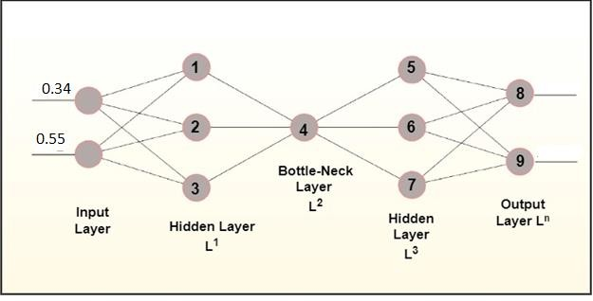

1. Repeat (2) for variational autoencoders with weights before mean and standard deviation are initialized as 0.5. Show only forward pass and discuss what is needed during backward pass including necessary derivatives to obtain change in weights before mean and standard deviation [**30 Points]**
2. Complete example Examples 2-1 - 2.16 **[30 Points]**